Ideation Phase
Define the Problem Statements

Date | 30 November 2025
Team ID
Project Name | Freelancing Application
Maximum Marks | 2 Marks

Customer Problem Statement Template:
This document identifies major challenges experienced by freelancers and clients within online job marketplaces and uses these findings to shape the Freelance Finder platform.
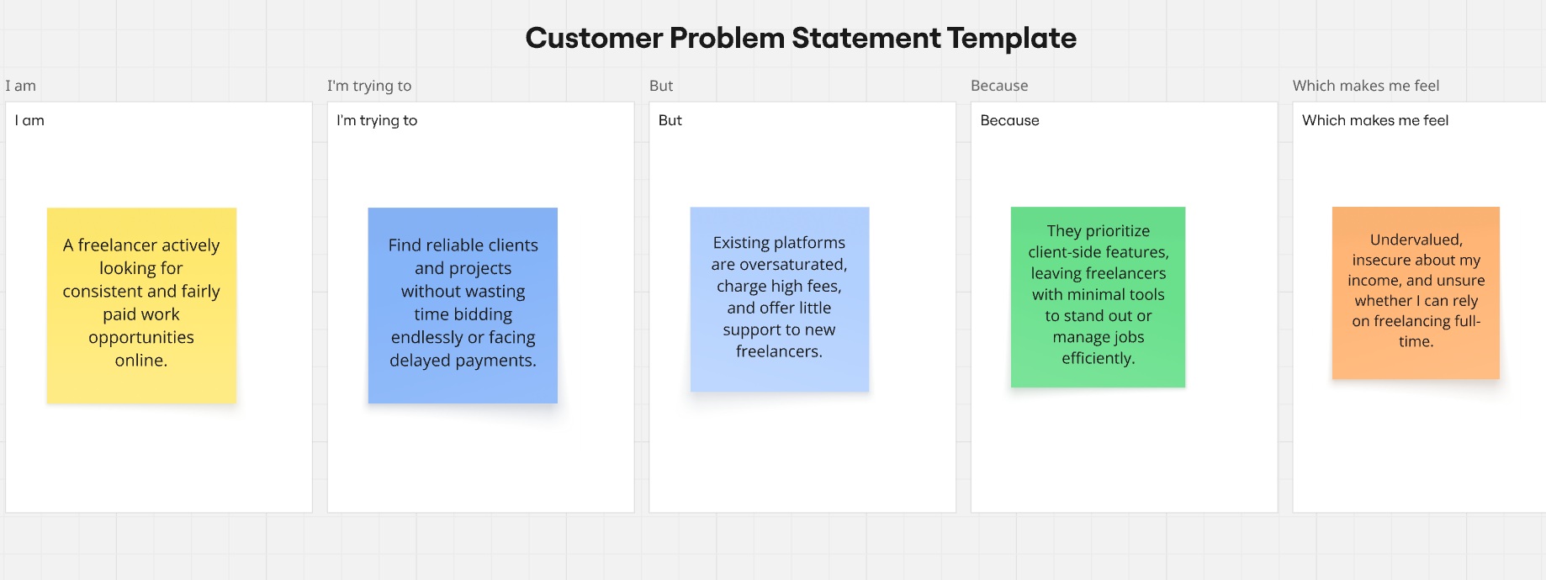

PS No. | I am… | I’m trying to… | But… | Because… | Which makes me feel…
PS–1 | A freelance web developer depending on short-term work for income. | Consistently secure quality projects that match my skill level and experience. | Clients often prioritize the lowest price instead of skill fit, and competitive offshore pricing makes it harder for me to win fair-paying work. | Many freelance platforms are price-focused rather than quality-driven, making it harder for experienced developers to stand out. | Demotivated and undervalued, questioning the long-term sustainability of freelancing.
PS–2 | A graphic designer with several years of professional freelance experience. | Showcase my portfolio effectively and attract high-value clients. | Existing platforms provide limited tools for personal branding, and my work blends into a large crowd of designers. | Project selection is mostly based on ratings or budgets rather than creative capability. | Overlooked and unrewarded despite strong expertise, losing premium opportunities to lower-priced competitors.
PS–3 | A startup founder or small business owner. | Quickly locate trustworthy freelancers without spending excessive time on screening and interviews. | Most platforms display inconsistent freelancer profiles, unclear pricing, and uneven quality. | There are no reliable systems for skills validation, quality scoring, or verified portfolios. | Uncertain about hiring decisions, anxious about outcomes, and frustrated with wasted time and resources.

